

|  |
| --- |
| UX REPORT |
|  |
| HUISTER  Authored by: Calvin Kwan |



|  |
| --- |
| 10 Design Principles Nielsen & Molich  1. **Visibility of system status**   Huister application use toast for every user action which will notify user after they do an action     1. **Match between system and real world**   Huister application use icons so user can easily understand how to interact with the application     1. **User control and freedom**   A forgot password feature has been implemented to give user control over their own account if they forget their password     1. **Error prevention**   When user insert an invalid input, the application will send an error message     1. **Help users recognize, diagnose, and recover from errors**   Huister has a confirmation message when they are about to do an irreversible action     1. **Consistency and standards**   Huister using standardize design for each page   * Owner Page      * Customer Page      1. **Recognition rather than recall**   Huister use an suggestion feature for certain component to help user doing what they want to do     1. **Flexibility and efficiency of use**   Huister use select filter that can be typed by user so it will help filtering properties efficiently     1. **Aesthetic and minimalist design**   Huister Implement icons to make the design more minimalistic     1. **Help and documentation**   Huister will implement a readme at its github repository after all functionality has been implanted  **Overall Analysis**  Huister has followed most of the design principles. After the project finished, the offline documentation in github repository will be added. |

Feedbacks

1. First Feedbacks
   1. First User
      * Name : Shereen Kwan
      * Occupation : Student
      * Relation : Developer’s sister
      * Feedbacks :
        + Change the rent icon because cart icon is misleading
        + Make the first shown tab for user is properties tab
   2. First User
      * Name : Gallen Anderson Teos
      * Occupation : Business Owner
      * Relation : Developer’s friend
      * Feedbacks :
        + Make the first shown tab for user is properties tab
        + Add change password to user profile
        + Change the tab name for dashboard into rent for customer
        + Change the tab name for dashboard into report for owner

IMPROVEMENT

* Change navbar according to feedbacks
* Owner navbar



* Customer navbar



* Adding change password button to user page

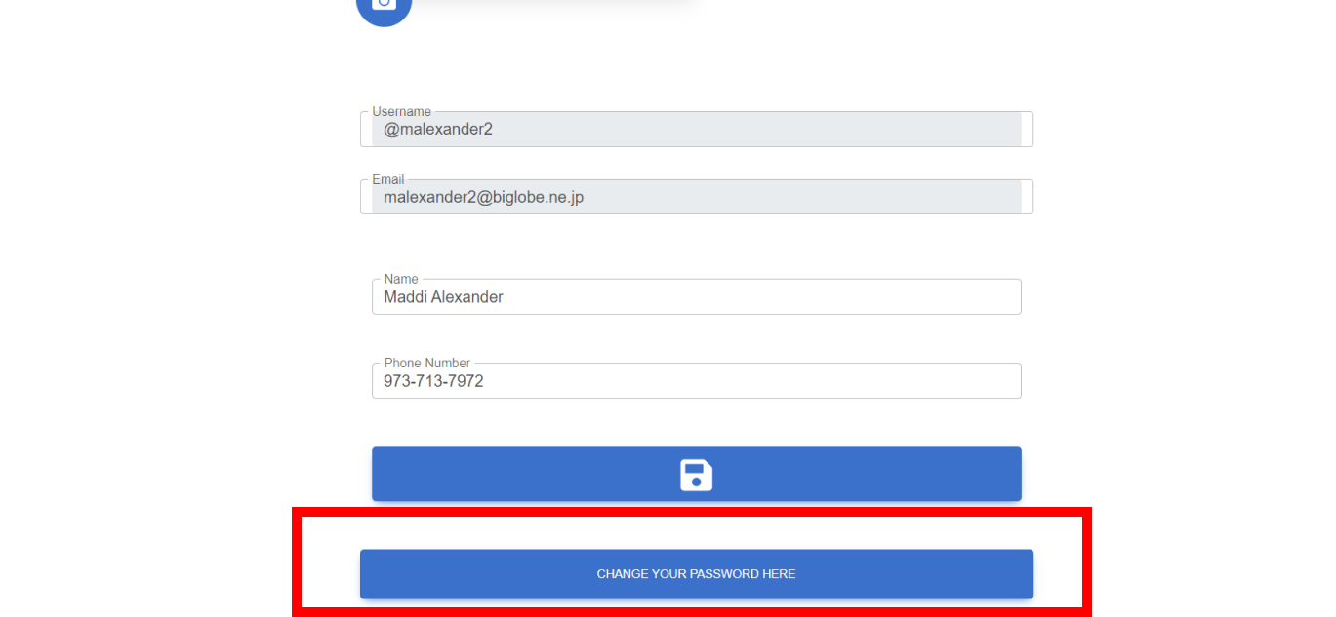

* Change rent icon

